**Subject**: Letter of Endorsement of AWS Cloud Clubs - Philippines Student Executives

Good day!

We are pleased to formally certify and recognize the legitimacy of the following student executives of [AWS Cloud Clubs](https://aws.amazon.com/developer/community/students/cloudclubs/?community-captains-all.sort-by=item.additionalFields.sortPosition&community-captains-all.sort-order=asc&awsf.filter-location=*all&awsf.filter-year=*all) - Philippines. These individuals have successfully undergone our comprehensive assessment and qualification process to ensure their competency and alignment with our organization's goals and standards.

May this document be the overall assessment and qualifications, verifying their eligibility and official designation within our organization.

**About Us**

AWS Cloud Clubs - Philippines is a nationwide initiative that aims to establish a vibrant and supportive community for students interested in AWS and cloud technologies. Through our university chapters, we strive to foster unity, partnership, and shared learning across the country.

We believe that by cultivating an interconnected and empowered community, we can help bridge the gap between students and cutting-edge technology, providing them with the resources and knowledge needed to thrive in the ever-evolving tech landscape.

**Our Mission and Vision**

We envision a future where students can leverage the power of AWS to drive business growth and create a lasting societal impact. Our mission is to:

* Foster a deeper understanding of cloud computing and its crucial role in modern technology.
* Equip students with practical expertise in AWS technologies, covering areas such as Security, AI, Data Analytics, and Cloud Technology.
* Empower students to apply their knowledge in real-world scenarios, preparing them for success in their future careers.

We deeply appreciate your partnership and continued support in our efforts to develop the next generation of cloud professionals. Should you require further clarification or additional documentation, please do not hesitate to contact us.

Attached are the requested validation IDs and curriculum vitae.

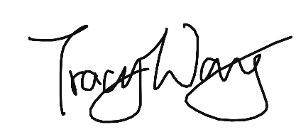

Regards,

**TRACY (CUI WANG) WANG**

Community Program Manager,

Amazon Web Services

wangcc@amazon.com

**Isaeus B. Guiang**  
Regional Captain

Student ID:

Curriculum Vitae:

https://app.box.com/s/959k6foshtxlgxgopcgqbh8duemqgmkd

**Kate Danielle Callao**VP and Chief Evangelist

Student ID:

Curriculum Vitae:

https://drive.google.com/file/d/1ZBx9cyEOgFa21M7UmYhyThgsMBg7dvSm/view?usp=sharing

**Kimi G. Villareal**Director for Marketing

Student ID:

Curriculum Vitae:

https://drive.google.com/file/d/1J3vvRH5YNwju8h8WuBjbhXCJWbjMPKCI/view?usp=sharing

**Charles Justin Lee A. Condolon**Director for Operations

Student ID:

Curriculum Vitae:

https://drive.google.com/file/d/1zmn11QGrvfE_Sqh6L3Z8qeQxQfWXuiO5/view?usp=sharing

**John Danmel C. Laranga**Director for Resources

Student ID:

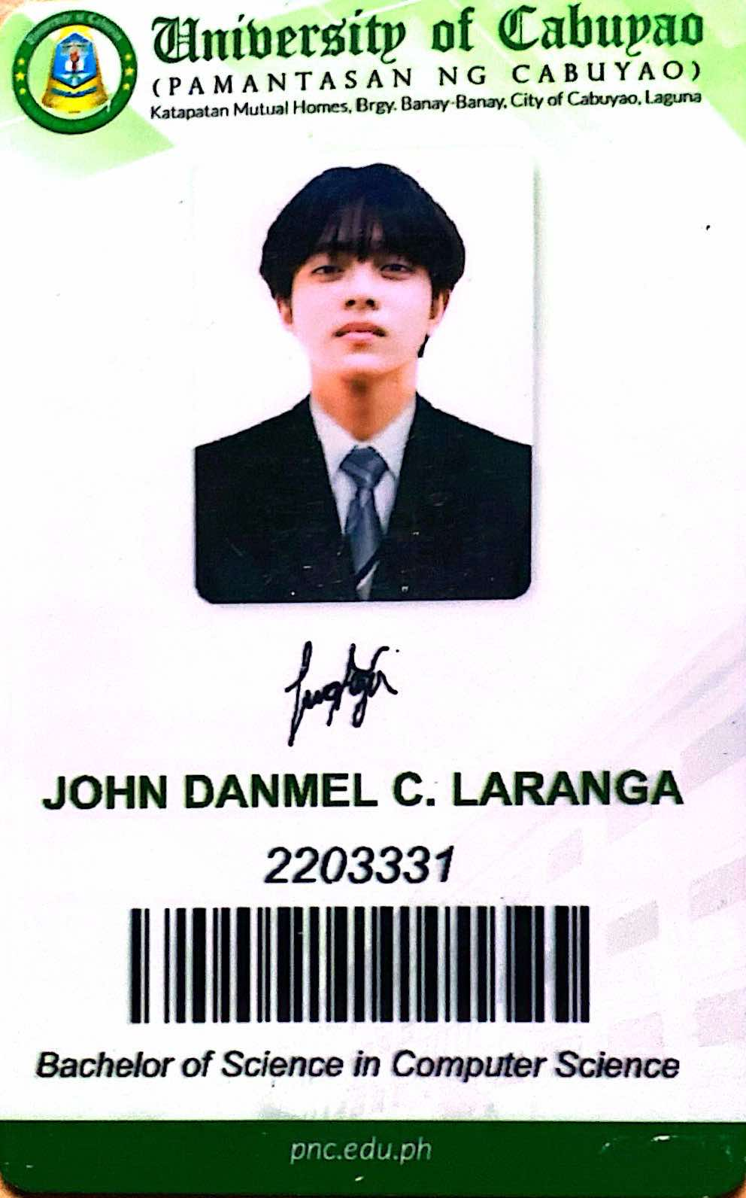

Curriculum Vitae:

https://drive.google.com/file/d/17lV5oYg_DOhIQI077-rFFLXI3eTV2bF0/view

**Darryl John L. Cainday**  
Director for Relations

Student ID:

https://drive.google.com/file/d/1zOX8azUEFWKIZFHl3qhnOp23oqHy9xqD/view?usp=sharing

Curriculum Vitae:

**Mark Achiles G. Flores Jr.**Director for Technology

Student ID:

https://drive.google.com/file/d/15adBpPWHXPqMPPWFbknVlJOSVPgNJIPT/view

Curriculum Vitae:

**Kenneth Hular**  
Director for Learning Clubs

Student ID:

https://drive.google.com/file/d/1y0WS0bSJyMlnFTU4dX4l59xLKsKqn_yv/view?usp=sharing

Curriculum Vitae:

**Cilla C. Adlawan**Director for BuildHers+ Student-Led Initiatives

Student ID:

Curriculum Vitae:

https://drive.google.com/file/d/16HI1wDzg4rvC2nRQBmN9nQ-m-2Nq2Ndv/view?usp=drivesdk